**A PROJECT REPORT**

**ON**

**“ONLINE NOTES SHARING” SUBMITTED FOR THE SESSION 2021-2022**

***This Project is submitted in partial fulfillment of the requirement for the award of the Master in Computer Application (MCA)***

**

*Guided By:- Submitted By:-*

***Prof.Miss.Shushma jaiswal 1) SRIJAN BHUWAL***

***Enroll no:- ggv/20/05061***

***Roll no.:-20606057***

*Submitted to:-*

**PROJECT WORK EVALUTION**

|  |  |  |
| --- | --- | --- |
| **1.** | **Candidate Name :** | **SRIJAN BHUWAL** |
| 2. | Project title : | ONLINE NOTES SHARING |
| 3 | Software Base : | PHP,HTML,CSS,MYSQL,JAVASCRIPT |
| 4 | Study Centre Code, Name & address: | Gurughasidas University |
| 5 | Submitted for Course and year | MCA(2021-2022) |
| 6 | Group Evolution : |  |

(PROJECT REPORT AND CD EVOLUTION MARKS)

|  |  |  |  |
| --- | --- | --- | --- |
| Particular | Marks Out of | Marks Awarded | External Examiners Name & Signature |
|  |  |  |  |

2



**CERTIFICATE**

This is to certify that the project entitled **“ONLINE NOTES SHARING”** submitted in partial fulfillment of the **MCA.** to the Gurughasidas university**, Bilaspur (C.G.),** done by “**SRIJAN BHUWAL** ” is an authentic work carried out by him under my guidance. This project is carried by project members.

**Guided by:- Prof.SHUSHMA JAISWAL**

**CSIT Department**

**Gurughasidas university, Bilaspur(C.G.)**

3



**SELF-CERTIFICATE**

This is to certify that the project “**ONLINE NOTES SHARING** ” has been completed and requirements are fulfilled and submitted by “ **SRIJAN BHUWAL**” under the guidance of **ProF.Shushma Jaiwal,** department of Computer Science and information technology, **Gurughasidas university, Bilaspur (C.G.).**

This report has not been submitted to any other University/Institute for award of any other Diploma/Certificate.

***Submitted By:-***

***NAME: SRIJAN BHUWAL ENROLLNO: ggv/20/05061***

***Roll no.:-20606057***

4



**ACKNOWLEDGEMENT**

We take this opportunity to acknowledge the sincere co-operation extended to us, during the course of our project and Master course.

We express our sense gratitude and appreciation to all who are indebted on various accounts. Thus we endeavor to enlist a few of them. We extend a sincere gratitude and profound sense of appreciation to **Prof.Shushma Jaiswal,** CSIT Department, Gurughasidas university, Bilaspur (C.G.) for excellent guidance and meaningful co-operation extended by her in perusing our project.

We also express out thanks to other staff member, colleagues for their co- operation. As without their kind co-operation and guidance, we could have completed this project.

***Name of Student :- SRIJAN BHUWAL***

5



### DECLARATION

It is hereby declare that the project “**ONLINE NOTES SHARING**” has been duly completed in the project is substantially and only submitted for the MCA, Gurughasidas University, Bilaspur (C.G.) and has been carried out under my direct supervision and guidance. This report or a similar report on the topic has not submitted for any other course undergone by the candidate.

**Dated.**:……………………..

(**Signature of the Candidates**)

6



**College notes gallery project is developed using PHP, JavaScript, and CSS. Talking about the project, it contains just a user side. All the management are done from the user side like uploading the reading materials. From the user side, the users can view the homepage and see the contents available there. Through this site, the college can maintain the student’s notes with more ease. He/She can upload them and also can edit them.**

**It is difficult for teacher’s to circulate their notes to each and every student whom is he/she teaching. College Notes Gallery provide an easy approach for both students and teachers to circulate the notes whether of any kind like lecture notes, assignment questions, question papers and all the important documents. The teachers and students can upload the documents fromanywhereand students can download it.**

**Overall it is managed by the admin.**

7



**Following is a list of functionality of the system. More functionality that you find appropriate can be added to this list. And, in places where the description of functionality is not adequate, you can make appropriate assumptions and proceed.**

**Users of the system:**

**Following are the requirements, which can be used to derive functional components:**

1. **Users need to register.**
2. **Facility to provide notes**
3. **Facility to view and downloads the notes.**
4. **User can view the previous college notes.**
5. **Notes can be download and upload in any format(.ppt,.pdf,)**
6. **After the approval of dministrator the notes will be uploaded.**

**The project titled “ONLINE NOTE SHARING” is designed using Active Server Pages**

**.PHP and SQL Server 2000 which runs under in Microsoft Windows Operating System**

8

**family. This project intends to provide the students with an environment where they can upload their notes online. By doing this, it will allow them to gain the basic knowledge about using any kind of project management system. This project has only a single agenda, that is, to allow students to upload their study materials online like google classroom. Here you have to sign up inorder to upload any kind of files.When you sing up then you can view the uploading dashboard. From there you can upload your files andlater on you can download them.Features such as Editing site content, user management, and site settings are the most essential feature of a site**



* + **Previously the management work was done manually.**
  + **It was a tedious job and also time consuming Therefore it was need to develop a computerized system which will reduce the complexity, improve efficiency and should be economically feasible.**
    - **.The main objective of ”online notes sharing” is to provide students free notes**
    - **This system will minimize the work time and complexity of the user.**
    - **By using this system the data will be stored in organized manner.**
    - **The system has GUI interface, so it is very user friendly.**

9



* **Multiple user access: Allows multiple type of users(teacher/student/admin) to login**
* **Functional Admin panel: Allows admins to manage the whole system**
* **CRUD functionalities: Allows all users to create,read,update and delete their notes in a managed format**
* **Profile update option: Allows users to update their profile/account details**
* **Secure registration and login option for users**
* **Allows students and teachers to download/upload their course notes easily**
* **Allows users to recover their password using forgot password option**

FEASIBILITY STUDY:

The feasibility of the project is analyzed in this phase and business proposal is put forth with a very general plan for the project and some cost estimates. During system analysis the feasibility study of the proposed system is to be carried out. This is to ensure that the proposed system is not a burden to the company. For feasibility

10

analysis, some understanding of the major requirements for the system is essential. Three key considerations involved in the feasibility analysis are

 ECONOMICAL FEASIBILITY

 TECHNICAL FEASIBILITY

 SOCIAL FEASIBILITY

ECONOMICAL FEASIBILITY

This study is carried out to check the economic impact that the system will have on the organization. The amount of fund that the company can pour into the research and development of the system is limited. The expenditures must be justified. Thus the developed system as well within the budget and this was achieved because most of the technologies used are freely available. Only the customized products had to be purchased.

TECHNICAL FEASIBILITY

This study is carried out to check the technical feasibility, that is, the technical requirements of the system. Any system developed must not have a high demand on the available technical resources. This will lead to high demands on the available technical resources. This will lead to high demands being placed on the client. The developed system must have a modest requirement, as only minimal or null changes are required for implementing this system.

11

SOCIAL FEASIBILITY

The aspect of study is to check the level of acceptance of the system by the user. This includes the process of training the user to use the system efficiently. The user must not feel threatened by the system, instead must accept it as a necessity. The level of acceptance by the users solely depends on the methods that are employed to educate the user about the system and to make him familiar with it. His level of confidence must be raised so that he is also able to make some constructive criticism, which is welcomed, as he is the final user of the system.

EXISTING SYSTEM

In general people share their ideas, queries and answers from their colleagues or friends through the intercom or direct manner. They need to spend time for their work.

DRAWBACKS

Some of the drawbacks are:

1. Details are enquired through phone.
2. It consumes more time
3. They don’t get proper notes.

PROPOSED SYSTEM

12

It is difficult to note down all the problems manually. Instead it is decided to develop an



**“ONLINE NOTE SHARING”** to ease the operation.

A system is required which is being capable of elimination all the problems and become useful to users and thus the new system is derived. Here we get a different view from different users.

BENEFITS

1. Interaction will be easier.
2. Users notes can be viewed by others.
3. Admin approved notes will be uploaded.

## HARDWARE REQIUREMNTS

The hardware used for the development of the project is:

PROCESSOR : PENTIUM III 866 MHz

13

RAM : 128 MD SD RAM

MONITOR : 15” COLOR

HARD DISK : 20 GB FLOPPY DRIVE : 1.44 MB CD DRIVE : LG 52X

KEYBOARD : STANDARD 102 KEYS MOUSE : 3 BUTTONS

# Software Requirements

**The software used for the development of the project is:**

**OPERATING SYSTEM : Windows 7/ XP/8/windows 10 SERVER SIDE SCRIPT : PHP**

**LANGUAGE : PHP**

**BACKEND : SQL SERVER 2000**

14



PHP:

WHAT IS PHP?

* **PHP is an acronym for "PHP Hypertext Preprocessor"**
* **PHP is a widely-used, open source scripting language**
* **PHP scripts are executed on the server**
* **PHP costs nothing, it is free to download and use WHAT IS PHP FILE?**
* **PHP files can contain text, HTML, CSS, JavaScript, and PHP code**
* **PHP code are executed on the server, and the result is returned to the browser as plain HTML**
* **PHP files have extension ".php"**

WHAT CAN PHP DO?

* **PHP can generate dynamic page content**
* **PHP can create, open, read, write, delete, and close files on the server**
* **PHP can collect form data**
* **PHP can send and receive cookies**
* **PHP can add, delete, modify data in your database**
* **PHP can restrict users to access some pages on your website**
* **PHP can encrypt data**

With PHP you are not limited to output HTML. You can output images, PDF files, and even Flash movies. You can also output any text, such as XHTML and XML.

WHY PHP?

15

* **PHP runs on various platforms (Windows, Linux, Unix, Mac OS X, etc.)**
* **PHP is compatible with almost all servers used today (Apache, IIS, etc.)**
* **PHP supports a wide range of databases**
* **PHP is free. Download it from the official PHP resource:** [**www.php.net**](http://www.php.net/)

TABLE:

A database is a collection of data about a specific topic.

VIEWS OF TABLE:

We can work with a table in two types,

1. **Design View**
2. **Datasheet View Design View**

To build or modify the structure of a table we work in the table design view.

We can specify what kind of data will be hold. Datasheet View

To add, edit or analyses the data itself we work in tables datasheet view

mode.

16

QUERY:

A query is a question that has to be asked the data. Access gathers data that answers the question from one or more table. The data that make up the answer is either dynaset (if you edit it) or a snapshot(it cannot be edited).Each time we run query, we get latest information in the dynaset.Access either displays the dynaset or snapshot for us to view or perform an action on it ,such as deleting or updating.

FORMS:

A form is used to view and edit information in the database record by record

1. **form displays only the information we want to see in the way we want to see it. Forms use the familiar controls such as textboxes and checkboxes. This makes viewing and entering data easy.**

Views of Form:

17

We can work with forms in several primarily there are two views, They

are,

* 1. **Design View**
  2. **Form View Design View**

To build or modify the structure of a form, we work in forms design view. We can add control to the form that are bound to fields in a table or query, includes textboxes, option buttons, graphs and pictures.

Form View

The form view which display the whole design of the form.

REPORT:

A report is used to vies and print information from the database. The report can ground records into many levels and compute totals and average

18

by checking values from many records at once. Also the report is attractive and distinctive because we have control over the size and appearance of it.



MACRO:

A macro is a set of actions. Each action in macros does something. Such as opening a form or printing a report .We write macros to automate the common tasks the work easy and save the time

Design is multi-step process that focuses on data structure software architecture, procedural details, (algorithms etc.) and interface between modules. The design process also translates the requirements into the presentation of software that can be accessed for quality before coding begins.

19

Computer software design changes continuously as new methods; better analysis and broader understanding evolved. Software Design is at relatively early stage in its revolution.

Therefore, Software Design methodology lacks the depth, flexibility and quantitative nature that are normally associated with more classical engineering disciplines. However techniques for software designs do exist, criteria for design qualities are available and design notation can be applied.

INPUT DESIGN

Input design is the process of converting user-originated inputs to a computer-based format. Input design is one of the most expensive phases of the operation of computerized system and is often the major problem of a system.In the project, the input design is made in various web forms with various methods.

For example, in the Admin form, the empty username and password is not allowed. The username if exists in the database, the input is considered to be invalid and is not accepted.

Output design

Output design generally refers to the results and information that are generated by the system for many end-users; output is the main reason for

20

developing the system and the basis on which they evaluate the usefulness of the application.

In the project, once questions are posted, It stores in to the data base. The questions are viewed and also the user who needs the details about the question can register and see the related answer which is to be posted this site.

DATABASE DESIGN

The database design is a must for any application developed especially more for the data store projects. Since the chatting method involves storing the message in the table and produced to the sender and receiver, proper handling of the table is a must.

In the project, login table is designed to be unique in accepting the username and the length of the username and password should be greater than zero.

The complete listing of the tables and their fields are provided in the annexure under the title ‘Table Structure’.

21





**User sign up**

Registration Module

Gender

Email Id

Confirm password

Password

User Name

Registration master

profession

**Admin login**

Password

Enter url

Web server

Password

admin

Check validity

Enter user id and password

22

## User login

Enter user id And password

User database

user

Enter url

Check validity



Web server

User login page

**The entity Relationship Diagram (ERD) depicts the relationship built. Beginning, once system requirement have been specified and analyzed, system design is the first of the three technical activities -design, code and test that is required to build and verify software.**

**The importance can be stated with a single word “Quality”. Design is the place where quality is fostered in software development. Design provides us with representations of software that can assess for quality. Design is the only way that we can accurately translate a customer’s view into a finished software product or system. Software design serves as a foundation for all the software engineering steps that follow. Without a**

**strong between the data objects. The ERD is the notation that is used to conduct the date modeling activity the attributes of each data object noted is the ERD can be**

23

**described resign a data object descriptions.**

**•**

**The set of primary components that are identified by the ERD are**

**•**

**Data object**

**• Relationships**

**• Attributes**

**•**

**Various types of indicators.**

**The primary purpose of the ERD is to represent data objects and their relationships.**

24

Admin

notes

signup

Edit profile

Upload notes

View notes

Download notes



Profile

### UNIT TESTING

The procedure level testing is made first. By giving improper inputs, the errors occurred are noted and eliminated. Then the web form level testing is made. For example storage of data to the table in the correct manner.

25

The dates are entered in wrong manner and checked. Wrong email-id and web site URL (Universal Resource Locator) is given and checked.

### INTEGRATION TESTING

Testing is done for each module. After testing all the modules, the modules are integrated and testing of the final system is done with the test data, specially designed to show that the system will operate successfully in all its aspects conditions. Thus the system testing is a confirmation that all is correct and an opportunity to show the user that the system works.

## VALIDATION TESTING

The final step involves Validation testing, which determines whether the software function as the user expected. The end-user rather than the system developer conduct this test most software developers as a process called “Alpha and Beta Testing” to uncover that only the end user seems able to find. The compilation of the entire project is based on the full satisfaction of the end users.

26

In the project, validation testing is made in various forms. In registration form Email id, phone number and also mandatory fields for the user is verified.



### VERIFICATION TESTING

Verification is a fundamental concept in software design. This is the bridge between customer requirements and an implementation that satisfies those requirements.

This is verifiable if it can be demonstrated that the testing will result in an implementation that satisfies the customer requirements.

Inadequate testing or non-testing leads to errors that may appear few months later. This will create two problems

* **Time delay between the cause and appearance of the problem.**
* **The effect of the system errors on files and records within the system.**

Implementation is the most crucial stage in achieving a successful system and giving the user’s confidence that the new system is workable and effective. Implementation of a modified application to replace an existing one. This type of

27

conversation is relatively easy to handle, provide there are no major changes in the system.

Each program is tested individually at the time of development using the data and has verified that this program linked together in the way specified in the programs specification, the computer system and its environment is tested to the satisfaction of the user. The system that has been developed is accepted and proved to be satisfactory for the user. And so the system is going to be implemented very soon. A simple operating procedure is included so that the user can understand the different functions clearly and quickly.

Initially as a first step the executable form of the application is to be created and loaded in the common server machine which is accessible to all the user and the server is to be connected to a network. The final stage is to document the entire system which provides components and the operating procedures of the system.

### SCOPE FOR FUTURE DEVELOPMENT

Every application has its own merits and demerits. The project has covered almost all the requirements. Further requirements and improvements can easily be done since the coding is mainly structured or modular in nature. Changing the existing modules or adding new modules can append improvements. Further enhancements can be made to the application, so that the web site functions very attractive and useful manner than the present one.

28



29

# USER LOGIN

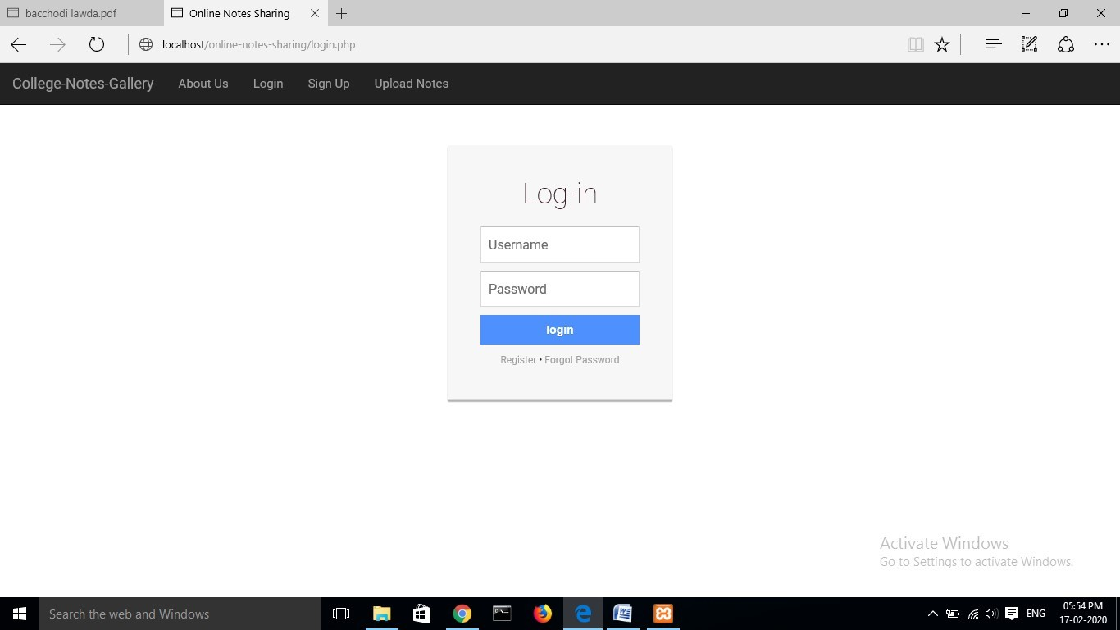

30

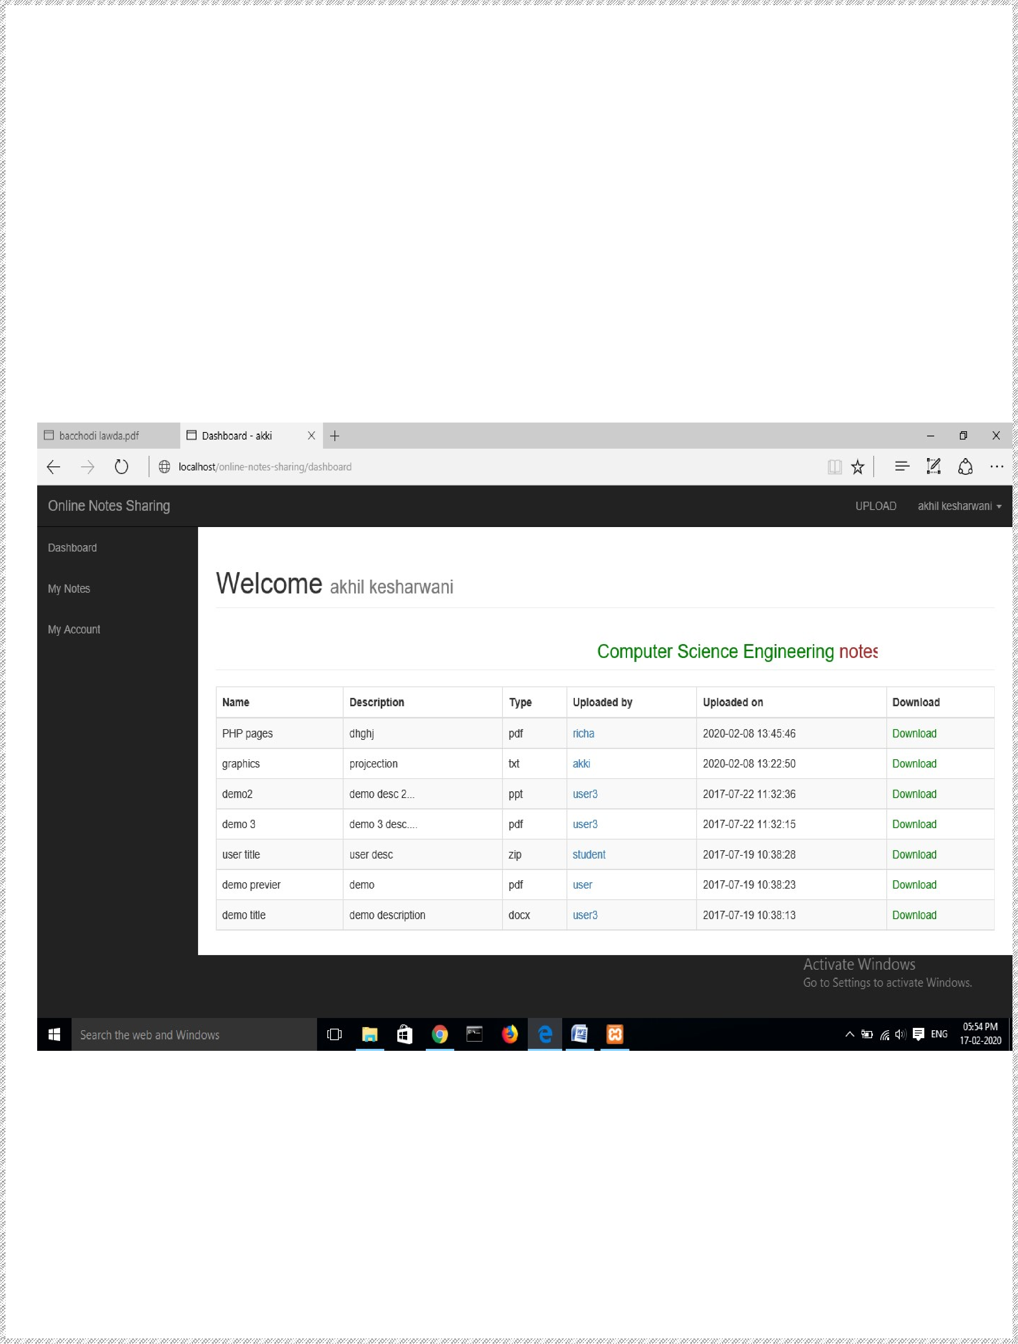

# USER DASHBOARD

31

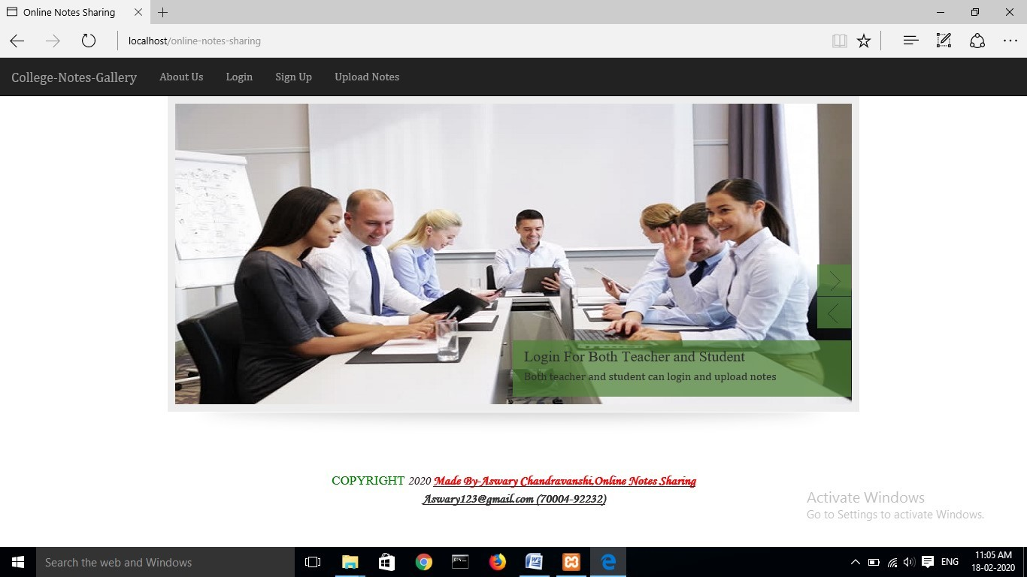

# HOME PAGE

32

# USER REGISTRATION

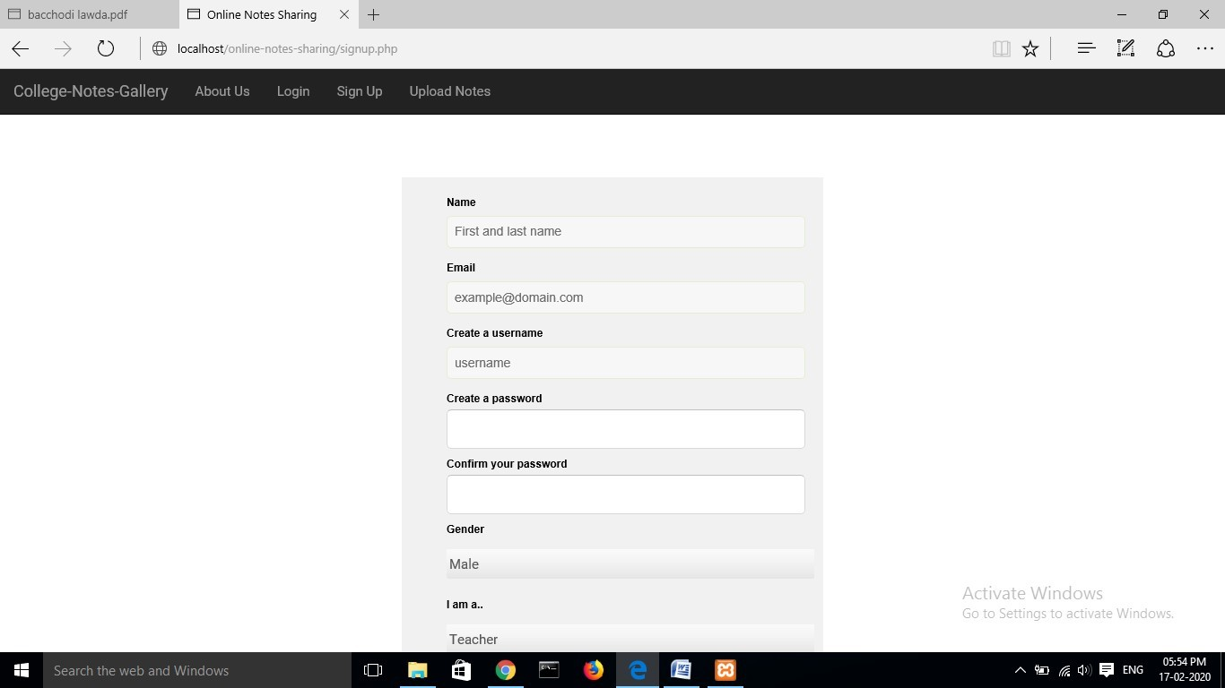

33

# ADMIN LOGIN



34

# USER PROFILE

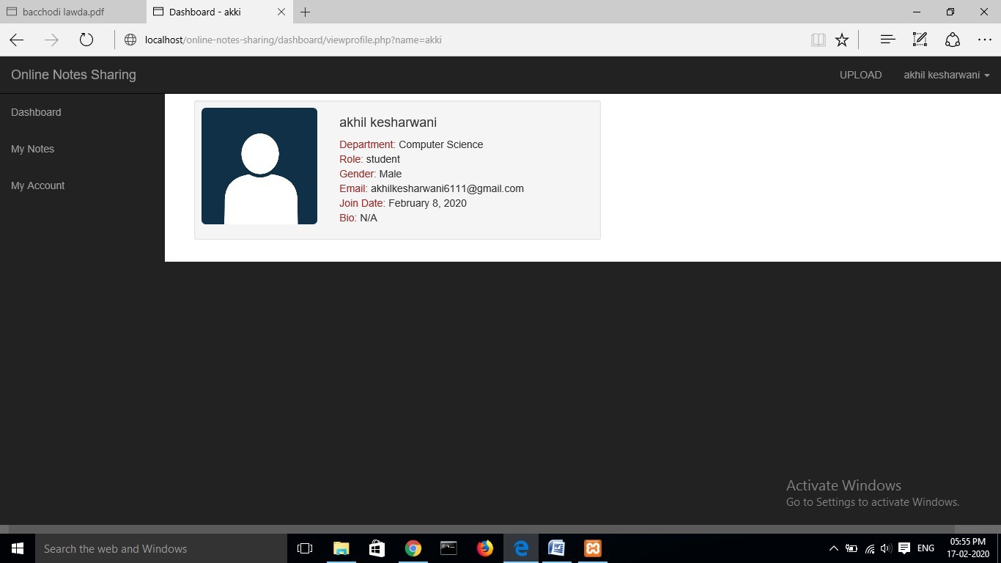

35

# ADMIN DASHBOARD

36



It is concluded that the application works well and satisfy the both registered and registered. The application is tested very well and errors are properly debugged. The site is simultaneously accessed from more than one system.

The site works according to the restrictions provided in their respective browsers. The speed of the transactions become more enough now. In this site the user can search the appropriate answers for their questions.. They can view their favorable questions, articles and inventions.

37





|  |  |  |
| --- | --- | --- |
|  |  |  |
|  | | |
|  |  |  |

1. **PHP MySQL Website Programming: Problem - Design – Solution byChris Lea, Mike Buzzard, Dilip Thomas , Jessey White-Cinis**
2. **Beginning PHP5, Apache, and MySQL Web Development (Programmer toProgrammer) by Elizabeth Naramore**
3. **MySQL/PHP Database Applications, 2nd Edition by Brad Bulger**
4. **How to Do Everything with PHP and MySQL by Vikram Vaswani**

38